**Part 1 :**

|  |
| --- |
| **Car** |
| **-Colour: String -EnginePower:int -Convertible: boolean -ParkingBrake: boolean** |
| **//constructors +Car() +Car(String Colour, int EnginePower, boolean Convertible, boolean ParkingBrake ) //getters +getColour():String +getEnginePower():int +getConvertible(): boolean +getParkingBrake(): boolean //setters +setColour(String colour):void +setEnginePower(int  EnginePower):void +setConvertible(boolean Convertible): void +setParkingBrake(boolean ParkingBrake): void //other logic methods +pressStartButton():void +pressAcceleratorButton():void +output(): void** |

**Part 2:**

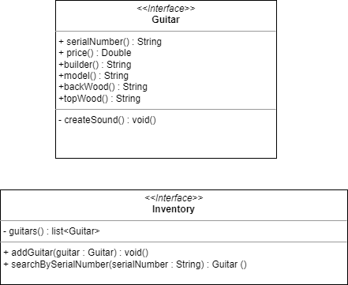

**Part 4:**

**- What is stored in the static heap, stack, dynamic heap?**

- Static heap, the class objects and static variables are stored.

- Stack, the method calls, local variables, and object references are stored.

- Dynamic heap, the objects are stored.

**- What are objects in the program?**

- The objects in the program are obj1 and obj2.

**- What is the state of obj1, obj2?**

- The state of obj1 is empty values for all fields.

- The state of obj2 is the values assigned during its constructor.

**- Do you access all fields of obj1 in the class Tester.java? Why?**

- No. - Because obj1’s fields are private and we can access all fields of obj1 in its class.

**- What is the current object when the program runs to the line “obj2.createSound();”?**

- It’s obj2.

**- In the method main, can you use the keyword “this” to access all fields of obj2? Why?**

- No. - Reason 1: main is a static method. - Reason 2: main is in Tester class, not in Guitar class.